Your contribution’s title
Author names, presenting author
Affiliation and contact information

Lorem ipsum dolor sit amet, consetetur sadipscing elitr, sed diam nonumy eirmod tempor invidunt ut labore et dolore magna aliquyam erat, sed diam voluptua. At vero eos et accusam et justo duo dolores et ea rebum. Stet clita kasd gubergren, no sea takimata sanctus est Lorem ipsum dolor sit amet. Lorem ipsum dolor sit amet, consetetur sadipscing elitr, sed diam nonumy eirmod tempor invidunt ut labore et dolore magna aliquyam erat, sed diam voluptua. At vero eos et accusam et justo duo dolores et ea rebum. Stet clita kasd gubergren, no sea takimata sanctus est Lorem ipsum dolor sit amet. Lorem ipsum dolor sit amet, consetetur sadipscing elitr, sed diam nonumy eirmod tempor invidunt ut labore et dolore magna aliquyam erat, sed diam voluptua. At vero eos et accusam et justo duo dolores et ea rebum. Stet clita kasd gubergren, no sea takimata sanctus est Lorem ipsum dolor sit amet. Lorem ipsum dolor sit amet, consetetur sadipscing elitr, sed diam nonumy eirmod tempor invidunt ut labore et dolore magna aliquyam erat, sed diam voluptua. At vero eos et accusam et justo duo dolores et ea rebum. Stet clita kasd gubergren, no sea takimata sanctus est Lorem ipsum dolor sit amet.Lorem ipsum dolor sit amet, consetetur sadipscing elitr, sed diam nonumy eirmod tempor invidunt ut labore et dolore magna aliquyam erat, sed diam voluptua. At vero eos et accusam et justo duo dolores et ea rebum. Stet clita kasd gubergren, no sea takimata sanctus est Lorem ipsum dolor sit amet. Lorem ipsum dolor sit amet, consetetur sadipscing elitr, sed diam nonumy eirmod tempor invidunt ut labore et dolore magna aliquyam erat, sed diam voluptua.

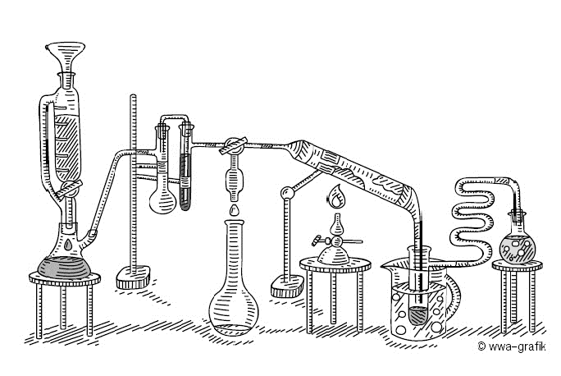
Figure 1. Lorem ipsum dolor sit amet, consetetur sadipscing elitr

Use Arial 12 for the text. Include as many references and figures as you want. But everything must fit on one page (A4) without changing the format!! Figures will be printed in grey scale.

References
1. A. Uthor, B. Ertha, Important Journal 42 (2020) 12345-12349
2. C. Harming, A. Uthor, B. Ertha, Yet Another Important Journal 13 (2020) 657-661

